Q1 Write a C++ program to print factorial of a number.

#include<iostream>

using namespace std;

int main()

{

    int num,factorial=1;

    cout<<"Enter Number To Find Its Factorial  ";

    cin>>num;

    for (int a=1;a<=num;a++) {

        factorial=factorial\*a;

    }

    cout<<"Factorial of Given Number is "<<factorial<<endl;

    return 0;

}

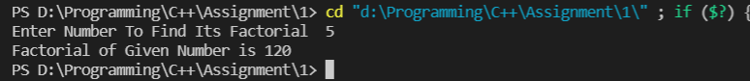

Q2 Write a C++ program to print factorial of a number through recursion.

#include<iostream>

using namespace std;

int factorial(int n);

int main()

{

int n;

cout << "Enter a positive integer: ";

cin >> n;

cout << "Factorial of " << n << " = " << factorial(n);

return 0;

}

int factorial(int n)

{

if(n > 1)

return n \* factorial(n - 1);

else

return 1;

}

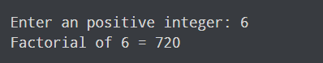

Q3 Write a C++ program to print sum of digits.

#include <iostream>

using namespace std;

int main()

{

int n,sum=0,m;

cout<<"Enter a number: ";

cin>>n;

while(n>0)

{

m=n%10;

sum=sum+m;

n=n/10;

}

cout<<"Sum is= "<<sum<<endl;

return 0;

}

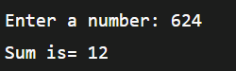

Q4 Write a C++ program to reverse given number.

#include <iostream>

using namespace std;

int main() {

int n, reversedNumber = 0, remainder;

cout << "Enter an integer: ";

cin >> n;

while(n != 0) {

remainder = n%10;

reversedNumber = reversedNumber\*10 + remainder;

n /= 10;

}

cout << "Reversed Number = " << reversedNumber;

return 0;

}

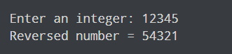

Q5 Write a C++ program to print multiplication of 2 matrices.

#include<iostream>

using namespace std;

int main()

{

    int i, j,N=4;

    int res[N][N]; // To store result

    int mat1[N][N] = { { 1, 1, 1, 1 },

                    { 2, 2, 2, 2 },

                    { 3, 3, 3, 3 },

                    { 4, 4, 4, 4 } };

    int mat2[N][N] = { { 1, 1, 1, 1 },

                    { 2, 2, 2, 2 },

                    { 3, 3, 3, 3 },

                    { 4, 4, 4, 4 } };

 int  k;

    for (i = 0; i < N; i++) {

        for (j = 0; j < N; j++) {

            res[i][j] = 0;

            for (k = 0; k < N; k++)

                res[i][j] += mat1[i][k] \* mat2[k][j];

        }

    }

    cout << "Result matrix is \n";

    for(i=0;i<=N;i++){

        for(j=0;j<=N;j++)

        cout<<res[i][j]<<" ";

        cout<<endl;

    }

    return 0;

}

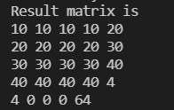

Q6 Write a C++ program to convert decimal number to binary.

#include <iostream>

#include <cmath>

using namespace std;

// function prototype

int convert(long long);

int main() {

long long n;

cout << "Enter a binary number: ";

cin >> n;

cout << n << " in binary = " << convert(n) << " in decimal";

return 0;

}

// function definition

int convert(long long n) {

int dec = 0, i = 0, rem;

while (n!=0) {

rem = n % 10;

n /= 10;

dec += rem \* pow(2, i);

++i;

}

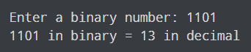

Q7 Write a C++ program to convert number in characters.

// C++ program to convert number in characters

#include<bits/stdc++.h>

using namespace std;

void NumbertoCharacter(int n)

{

int rev = 0, r = 0;

// To calculate the reverse of the number

while (n > 0) {

// The remainder will give the last digit of the number

r = n % 10;

rev = rev \* 10 + r;

n = n / 10;

}

while (rev > 0) {

// Extract the first digit of the reversed number

r = rev % 10;

// Match it with switch case

switch (r) {

case 1:

cout << "one ";

break;

case 2:

cout << "two ";

break;

case 3:

cout << "three ";

break;

case 4:

cout << "four ";

break;

case 5:

cout << "five ";

break;

case 6:

cout << "six ";

break;

case 7:

cout << "seven ";

break;

case 8:

cout << "eight ";

break;

case 9:

cout << "nine ";

break;

case 0:

cout << "zero ";

break;

default:

cout << "UnValid ";

break;

}

// Divide the number by 10 to get the next number

rev = rev / 10;

}

}

// Driver code

#include <iostream>

int main()

{

int n = 12345;

NumbertoCharacter(n);

return 0;

}



Q8 Write a C++ program to generate all the prime numbers between 1 and n, where n is a value supplied by the user.

#include <iostream>

using namespace std;

int main() {

int num, i, upto;

// Take input from user

cout << "Find prime numbers upto : ";

cin >> upto;

cout << endl << "All prime numbers upto " << upto << " are : " << endl;

for(num = 2; num <= upto; num++) {

for(i = 2; i <= (num / 2); i++) {

if(num % i == 0) {

i = num;

break;

}

}

// If the number is prime then print it.

if(i != num) {

cout << num << " ";

}

}

return 0;

}

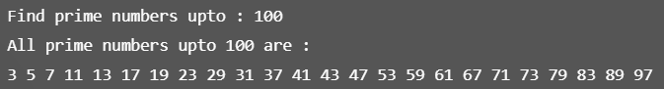

Q9 Write a C++ program to find both the largest and smallest number in a list of integers.

// Online C++ compiler to run C++ program online

#include<iostream>

using namespace std;

int main ()

{

int arr[10], n, i, max, min;

cout << "Enter the size of the array ";

cin >> n;

cout << "Enter the elements of the array ";

for (i = 0; i < n; i++)

cin >> arr[i];

max = arr[0];

for (i = 0; i < n; i++)

{

if (max < arr[i])

max = arr[i];

}

min = arr[0];

for (i = 0; i < n; i++)

{

if (min > arr[i])

min = arr[i];

}

cout << "Largest element " << max<<endl;

cout << "Smallest element " << min;

return 0;

}

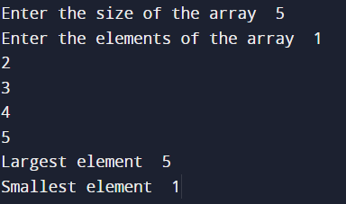

Q10 Write a C++ program to sort a list of numbers in ascending order.

#include <iostream>

using namespace std;

int main()

{

int arr[100];

int size, i, j, temp;

// Reading the size of the array

cout<<"Enter size of array: ";

cin>>size;

//Reading elements of array

cout<<"Enter elements in array: ";

for(i=0; i<size; i++)

{

cin>>arr[i];

}

//Sorting an array in ascending order

for(i=0; i<size; i++)

{

for(j=i+1; j<size; j++)

{

//If there is a smaller element found on right of the array then swap it.

if(arr[j] < arr[i])

{

temp = arr[i];

arr[i] = arr[j];

arr[j] = temp;

}

}

}

//Printing the sorted array in ascending order

cout<<"Elements of array in sorted ascending order:"<<endl;

for(i=0; i<size; i++)

{

cout<<arr[i]<<endl;

}

return 0;

}

